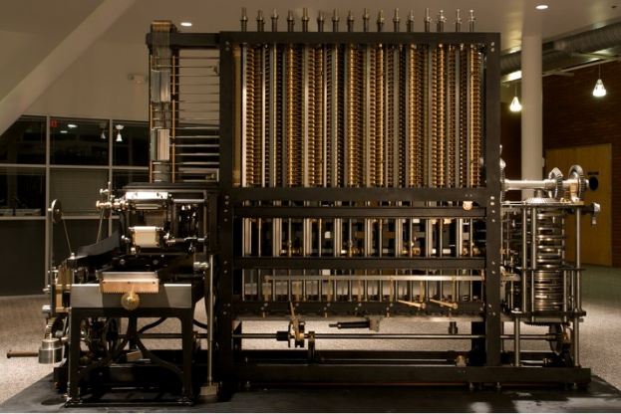
Ada Lovelace

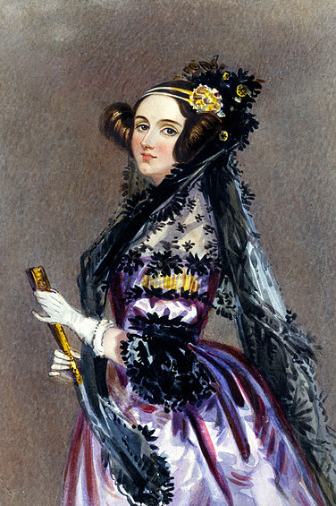
Ada Lovelace was born on 10th December 1815 in London and she died on 27th November, 1852 in London.
She wrote two books Flyology and PLUS.
Her parents were Lord Byron and Anne Isabella Milbanke.
Her mother was rapped four times.
Her parents were divorced and her mother stayed with Ada Lovelace.

Ada Lovelace was a mathematician, engineer, writer, translator, poet, program planner, inventor and also a computer scientist.

She also created the first program in the world. Ada Lovelace is very famous in Anglo-Saxon countries and in Germany. She added her program in the Babbage machine created by Louis-Frédéric Ménabréa.

