BARACK OBAMA

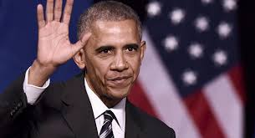
Barack Obama was born on August 4th 1961 in Hawaii, Honolulu.

He is black. His father is a black Kenyan and his mother is a white American.

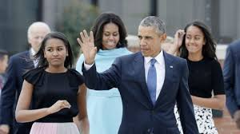

Barack Obama has been married to Michelle Robinson since 1992 and they have 2 children. Malia was born in 1998 and Natascha was born in 2001.

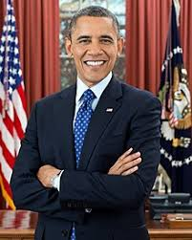

He is American. He studied at Columbia University in New York. He taught constitutional law in Chigago, Illinois. He won the Nobel Peace Price in 2009. He was a lawyer and he was the 44th president of the USA from 20 th January 2009 to 20th January 2017.

