Barbara Charline Jordan
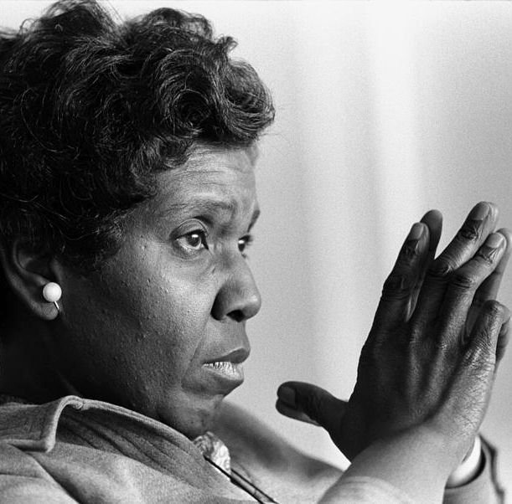

Barbara Charline Jordan was born on February 21st 1936 in Houston, Texas and she died in Austin, Texas on January 17th 1996. She was American, a homosexual and lived with Earl in 1960. That is what people told after her death.
She was a lawyer, a law teacher and one of the leaders of the American Civic Rights Movement. In 1956 she got her political science diploma and she got the Bachelor of Laws in 1959. She was a democrat, like most American people, and she was elected as senator. She became President of the Senate in Texas on March 21st 1967. She was elected as a representative from 1973 to 1979, the first Afro-American woman elected in Texas and first homosexual woman in Congress. She did a lot of things like the laws consumer Goods Pricing Act on May 14th 1975.

