Clara Barton
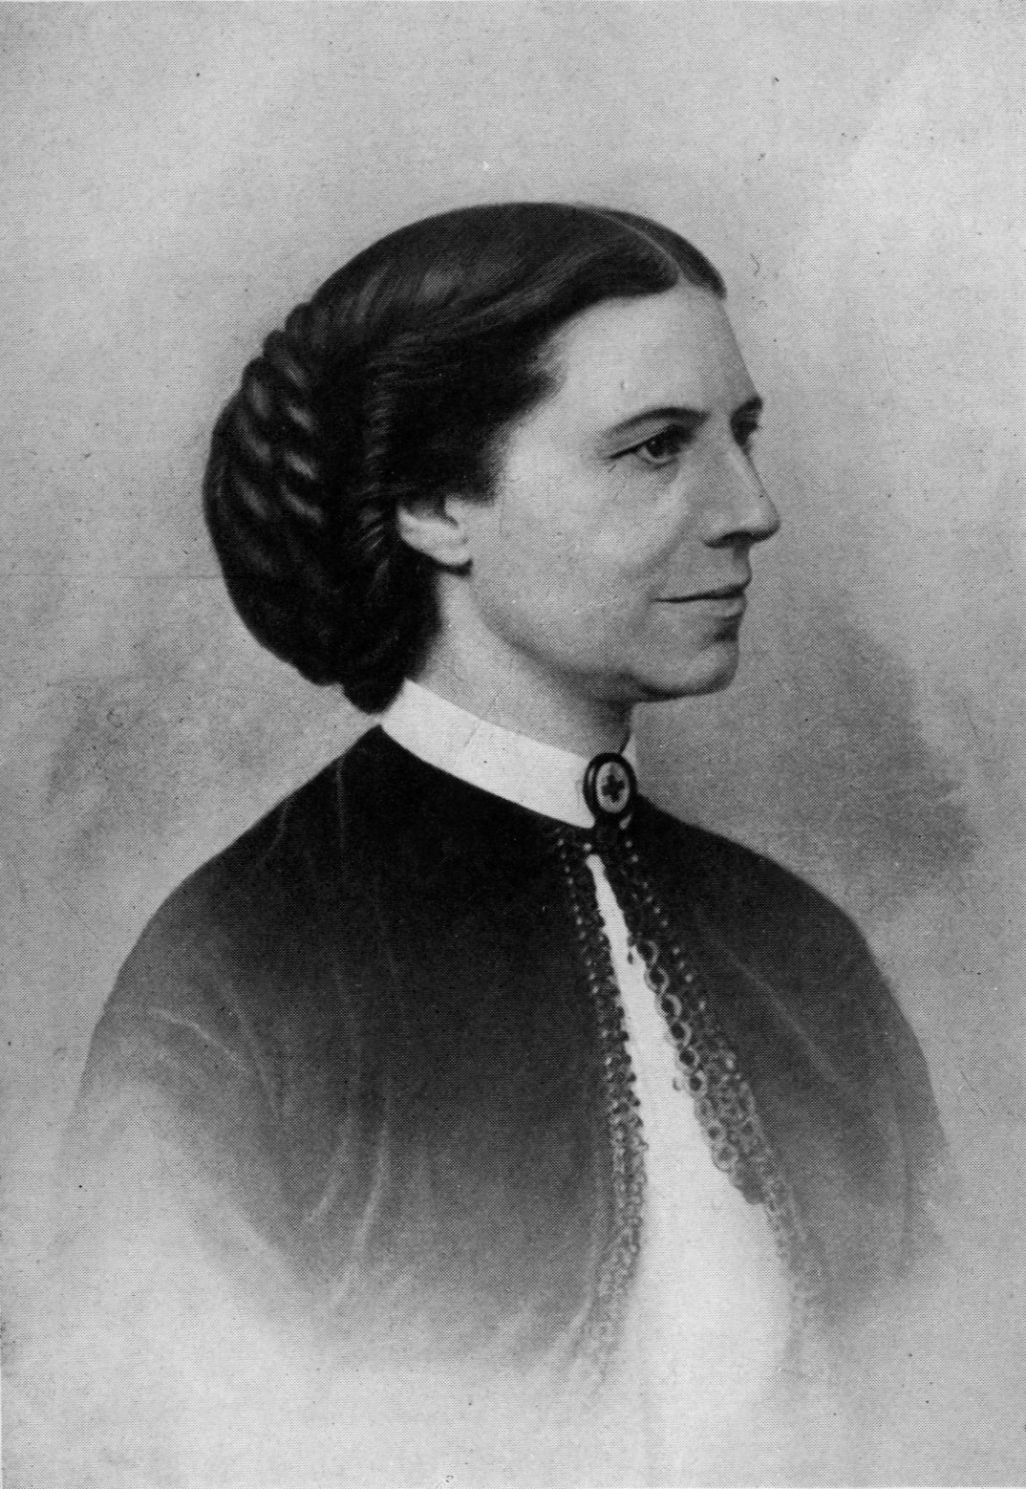

Clara Barton was a teacher, nurse and humanitarian American woman born on December 25th 1821

in Oxford, Massachusetts. She died at ninety on April 12th 1912 in Glen Echo, Maryland. Her

maternal name was Clarisse Harlowe Barton. Her parents were Sarah Barton and Stephen Barton.

She had four siblings: Sarah Barton Vassall, Stephen Barton, Dorothea Barton and David Barton.

She was the founder of the American Red Cross and the President of this association from May 21st

1881 to 1904. She wrote many books like The Story Of My Childhood in 1907 and A Story Of The

Red Cross in 1904. She was home-schooled and wonderful. She was also a shy and reserved child.

At 11 years old, her brother David fell from a roof. She took care of him for 2 years. When her

brother recovered, she felt different. She solved the problem by taking care of her sister’s children,

and then by learning to other kids how to read.



