COOKIES

Ingredients:
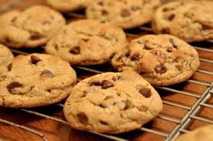
  - 510g of flour
  - 170g of caster sugar
  - 170g of brown sugar
  - 2 eggs
  - 1 teaspoon of bicarbonate of soda
  - 1 teaspoon of vanilla extract
  - 340g of chocolate chips
  - 200g of butter
  - A pinch of salt

Directions:

- Preheat the oven at 180°C.
- Mix the white sugar, brown sugar and butter.
- Add the eggs, vanilla extract, bicarbonate of soda and a pinch of salt. Mix all the ingredients and add the flour.
- Add the chocolate chips.Take a pastry tray and butter the tray. Drop small tablespoons onto the pastry tray.
- Bake for 12 minutes.


