EMMELINE PANKHURST

Emmeline Pankhurst was born on 15th July 1858 in Manchester in England. She was a British political woman. Her parents were involved in politics.
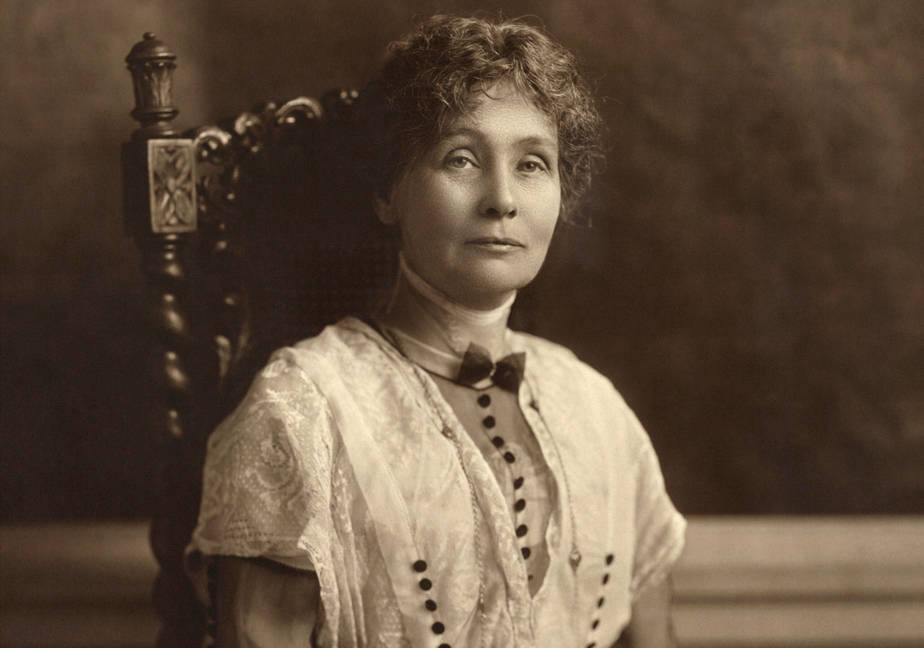
Her husband was Richard Pankhurst. With Richard, they took part in the National Society for Women’s suffrage. Richard Pankhurst died on 5th July 1898. In 1903 she created the Women Social and Political Union for Women’s rights. In 1918 she was allowed to vote at more than 30 years old. In 1960 she was elected at the board of directors in Manchester. She died on 14th July 1928 because she was sick in London at 69 years old.


