Harriet Jacobs

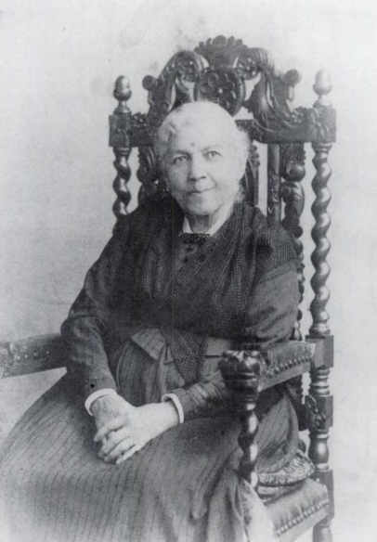
Harriet Jacobs was born in 1813 in Edenton, North Carolina and died on March 7th 1897 in Washington D.C. She was an American writer and a militant for the abolition of slavery.

She ran away from her master and abuser’s house. She was a free slave who gained her freedom in New York City. She joined an abolitionist network. She worked as a babysitter.

At night, she wrote her autobiography Incidents in the Life of a Slave Girl in 1861. Her author’s name was Linda Brent.

She gained her abolition due to her book because she explained the hell of slavery.

