Harriet Tubman

Harriet Tubman was born in 1820 in Maryland. All her family were slaves, so she became a slave too.
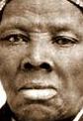
She escaped in 1849. Then she helped other slaves to escape. She wanted to fight against the inequality between men and women. Her real name was Araminta Ross. Her first husband was Nelson David but after she married John Tubman.

She had a nickname, Moise Black. She escaped because she fell ill so her market value as a slave dropped. The abolition of slavery was signed in 1865.

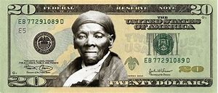
She was the first black woman to appear on an American banknote.

When she was young, she was hurt by a weight of one kilo. She kept sequels all her life. She thought she had premonitory dreams about the flight of the Jews. She died in 1913 in Auburn.

