Abraham Lincoln

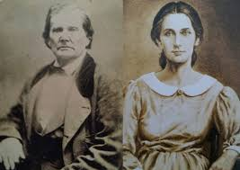
He lived in a poor family.
Abraham Lincoln was born on February 12th 1809 in Hardin, Kentucky and was murdered on April 15th 1865 in Washington DC.
On September 22nd 1862, Abraham Lincoln abolished slavery in the southern states.
This law allowed black people the right to vote and the equality with white people.
He was the sixteenth president of the United States.
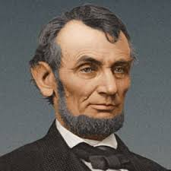
He was elected president of the United States in November 1860 and in November 1864.
He is the first Republican president in the history of the country.

