Pancakes

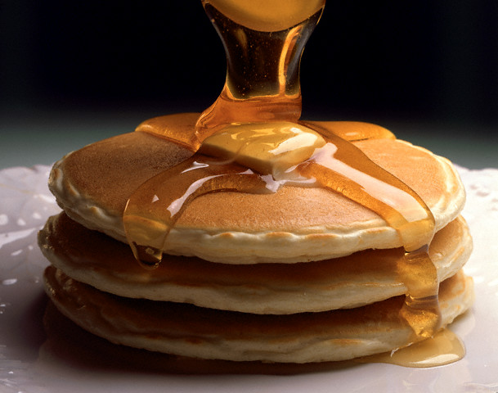
Ingredients

-250g flour
-30g sugar
-2 eggs
-baking powder
-65g butter
-salt
-30 cl milk

Preparation time :10 minutes
Cooking time:4 minutes

Put the flour, baking powder and sugar in a bowl. Add the eggs and mix. Add the salt.
Then add the melted butter, mix and add the milk.
Leave in the fridge for one hour.



