Prince William and Kate Middleton

Prince William was born on June 21st 1982 at St Mary’s Hospital in Paddington in London.

His full name is William Arthur Philip Louis. His brother is Harry. He was born on September 15th

1984. His children are George of Cambridge, Charlotte of Cambridge and Louis of Cambridge.
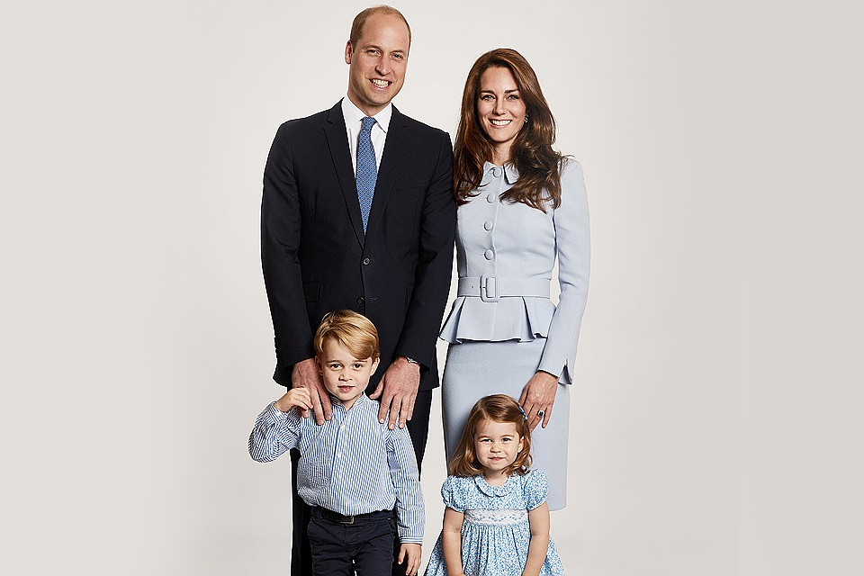
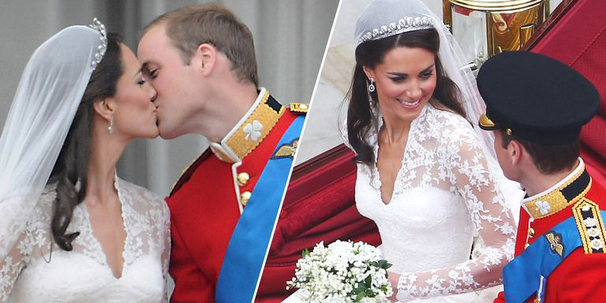

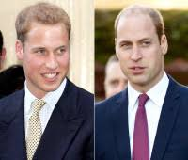
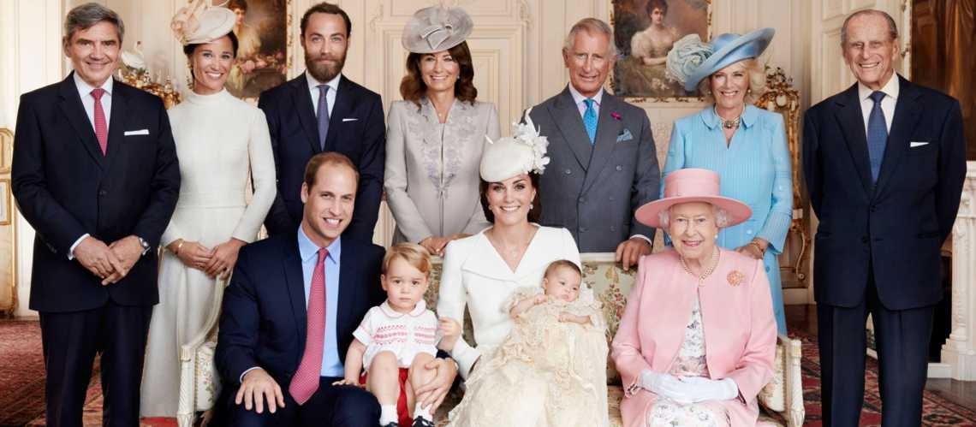

Catherine Middleton was born on January 9th 1982 in Reading. She is William’s wife. They live in Kensington Palace. She is the Duchess of Cambridge. Her sister is Pippa Middleton and her brother is James William Middleton.



