Coretta Scott King

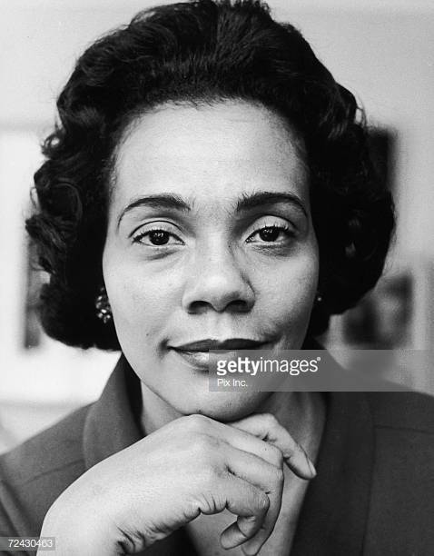
Coretta Scott King was a militant of the Civil Rights. She was born on 27th April 1927 in Heiberger, Alabama and she died on 30th January 2006 in Playas de Rosarito, Mexico. Coretta was married to Martin Luther King. She received several awards like The Nobel Peace Price and The Coretta Scott King Award for authors. She had four children, two sons and two daughters : Martin Luther King III, Dexter Scott King, Bernica King and Yolanda King. She was an American civil rights activist. She joined the civil rights movement in the 1950’s and 60’s. She got married to Martin Luther King in 1953. She worked as a public mediator.

