Queen Elizabeth II

Queen Elizabeth II was born on April 21st 1926 in Mayfair, London.

Her full name is Elizabeth Alexandra Mary.

Her sister is Margaret, she is dead. She died on February 9th 2002.

Her parents are dead. Her father, George VI, died on February 6th 1952 and her mother, Elizabeth
Bowes-Lyon, died on March 30th 2002.

She is married to Prince Philip Mountbatten who the Duke of Edinburgh.

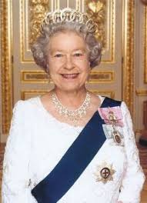
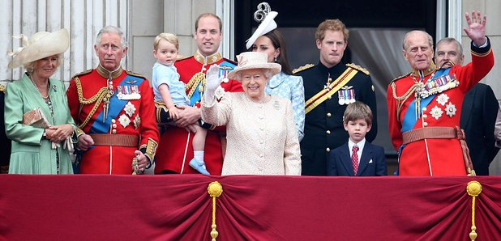
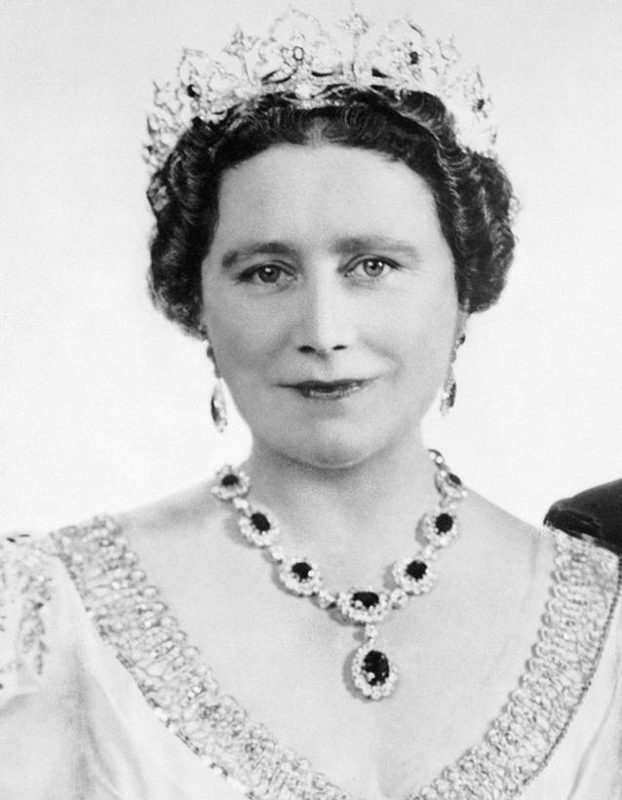
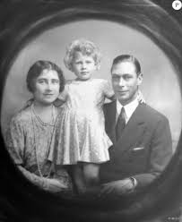
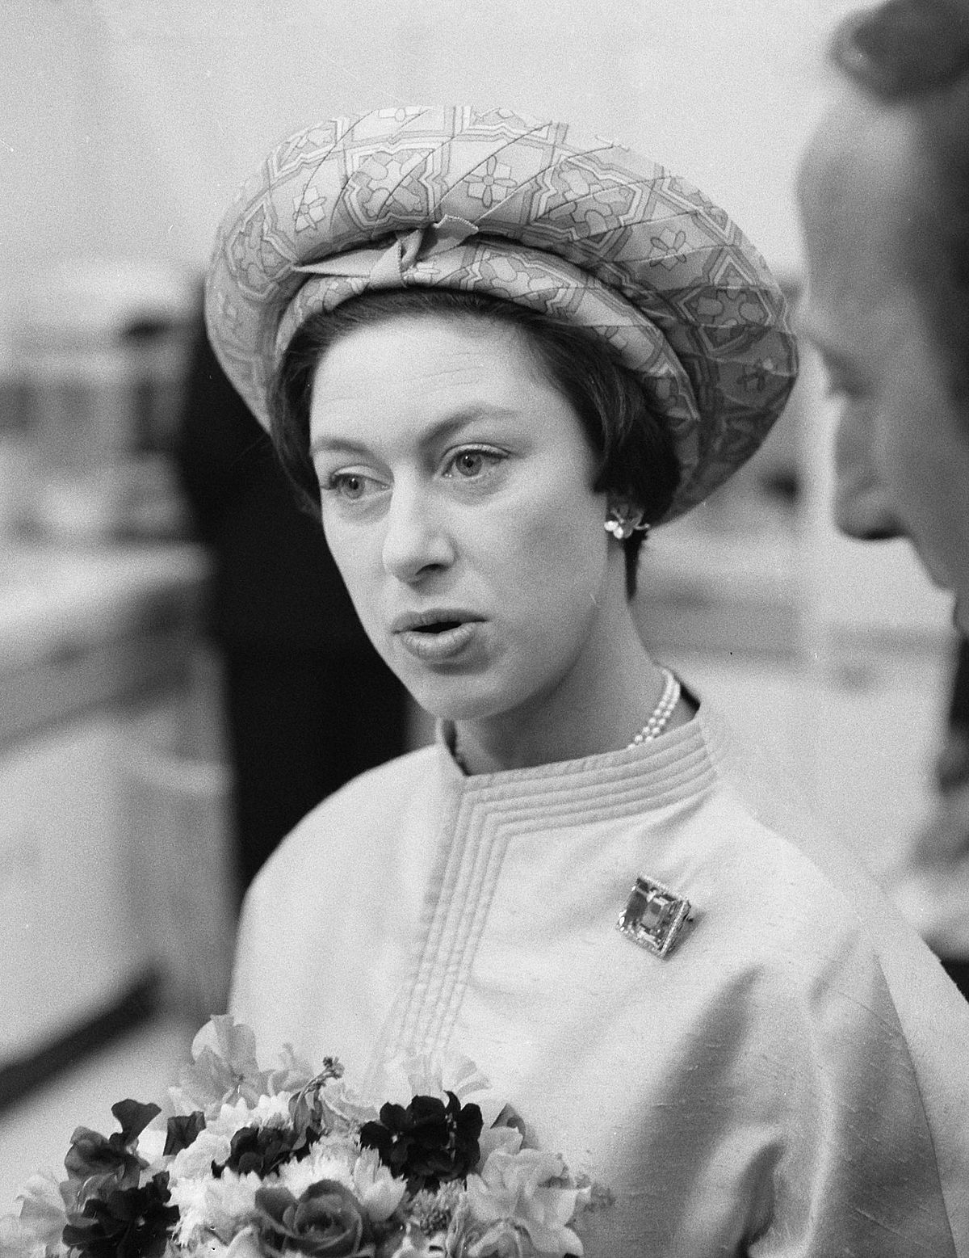
They have got four children, Charles, Anne, Edward and Andrew.

