ROSALIND FRANKLIN

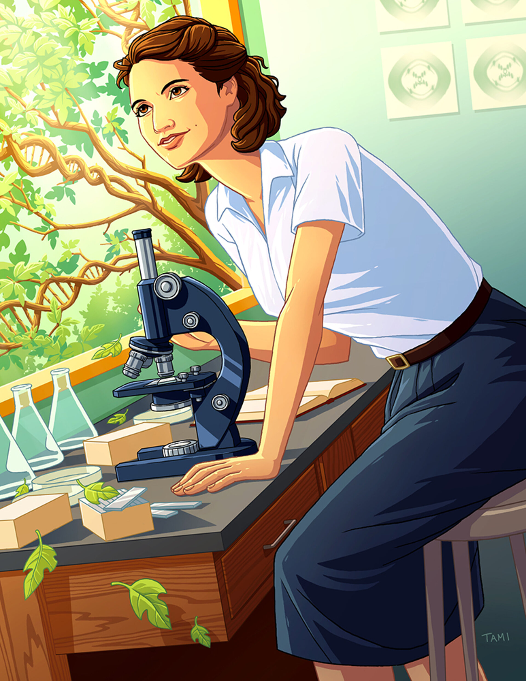
Rosalind Elsie Franklin was a famous molecular biologist and chemist.

She was born on 25th July 1920 in London. She became famous thanks to her discovery about the form of DNA (Deoxyribonucleic acid). She had a rich family.

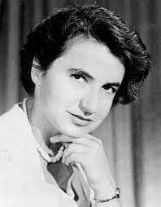
When she was 12 years old, she wanted to start a scientific career but her father didn’t agree. In 1938 she went to Newnham college at Cambridge University in the United Kingdom. In 1945 she had her doctorate.

She died before receiving the Nobel Prize because she had a cancer. She died in 1958 in Chelsea.


