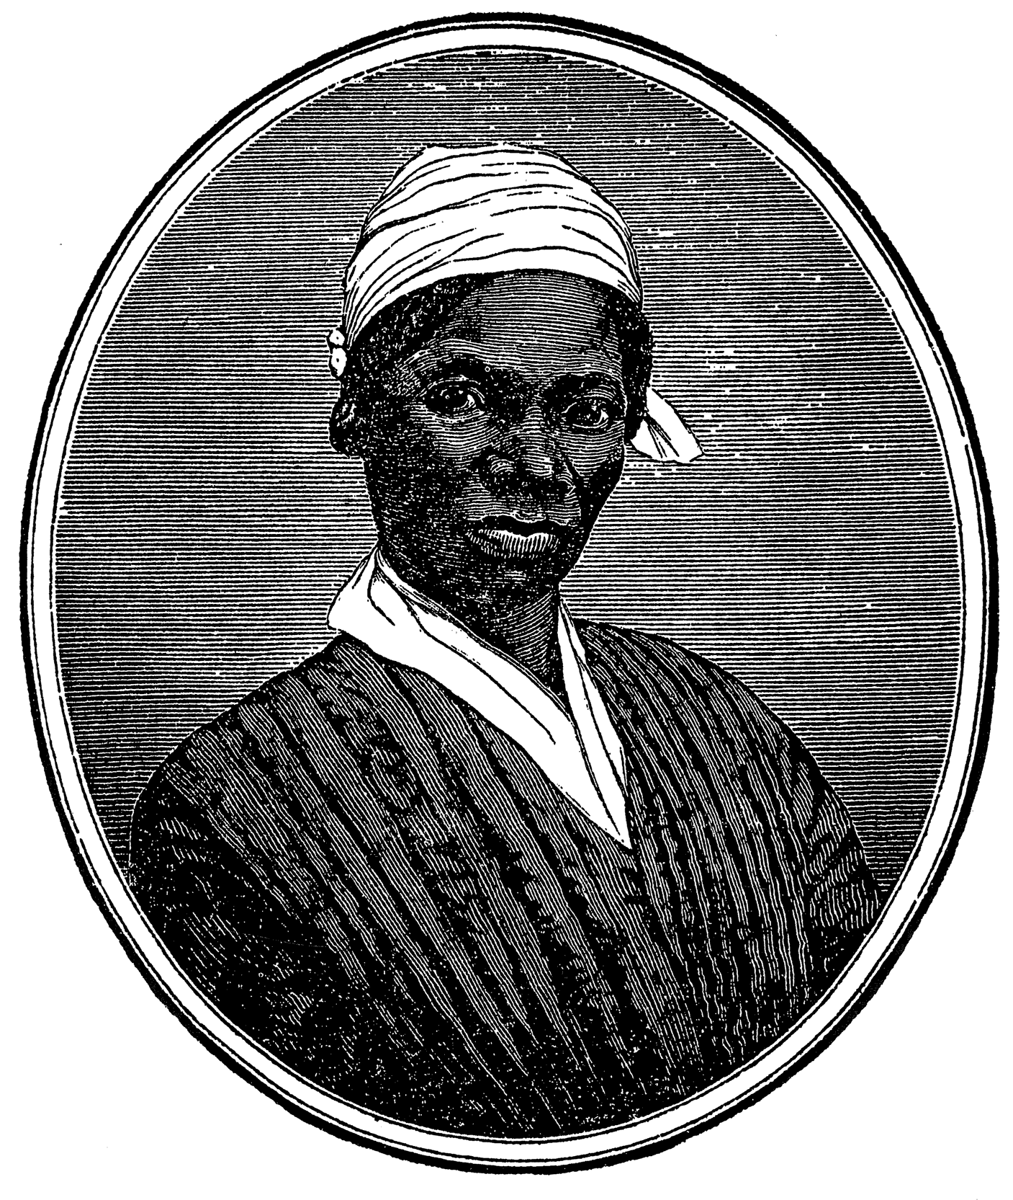
Isabella Baumfree

Isabella Baumfree, also called Sojourner Truth, was born in 1797 in Hurley, New York State. Sojourner Truth worked on human rights, she was a writer
and most of all, she fought for women's rights. Sojourner, daughter of James and Elizabeth Baumfree, was a slave in her life.
This woman was a Methodist. In 1827, Sojourner Truth escaped from John Dumont’s farm. He was her third master and he didn’t want
to let her go, just after the abolition of slavery. After her escape, Sojourner took refuge
in Canada. In 1841 this woman came to Northampton in Massachusetts and just 2 years later, she changed her name for Sojourner Truth. She participated in the association
of Northampton. She wrote her biography and 4 years later she published it. Sojourner Truth
became a defender of the movement of Women’s rights. Finally, in 1857, she went to
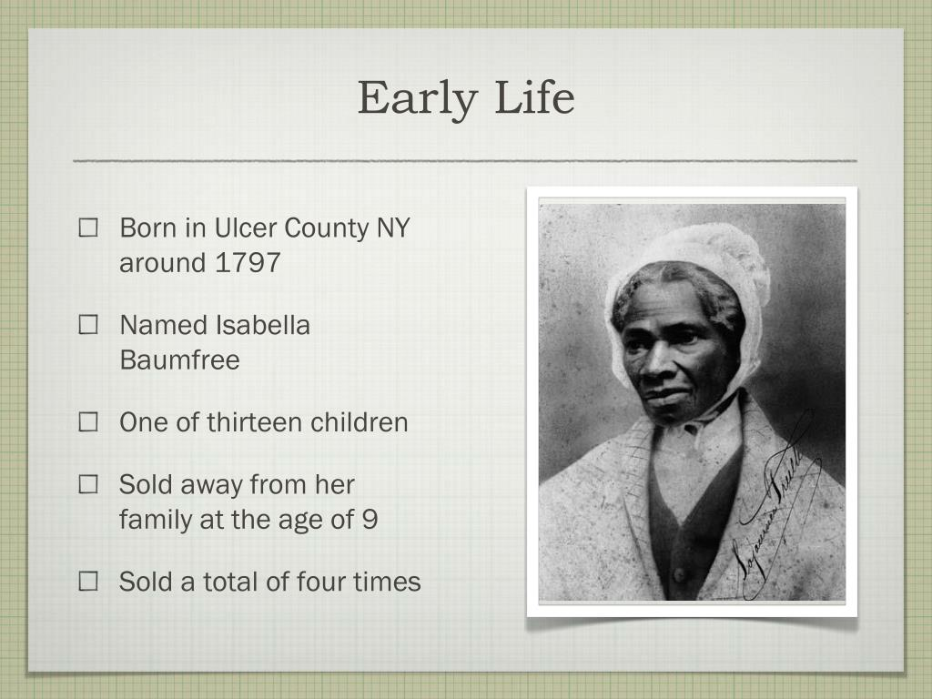
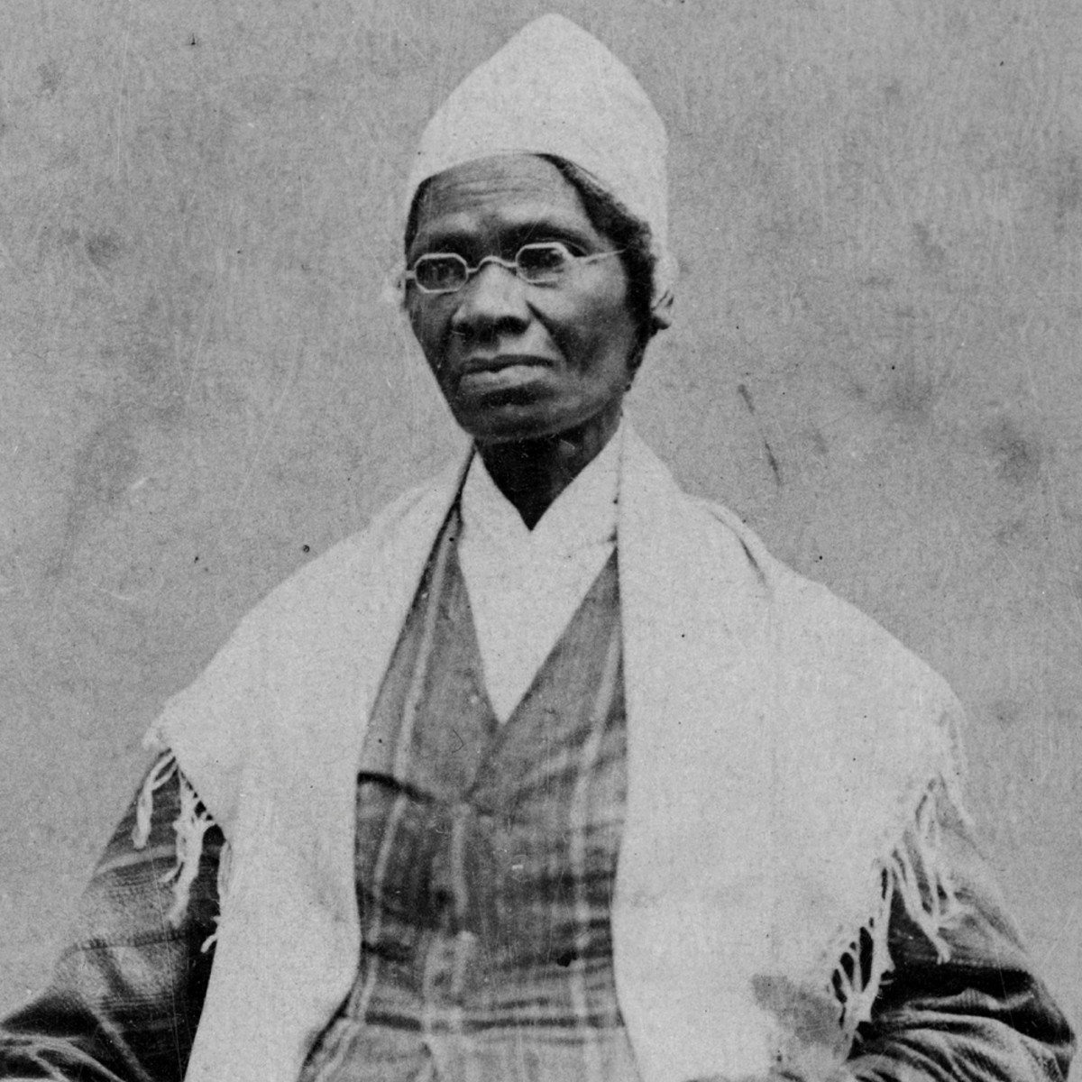
Michigan to talk about her movement and organized some food collects.

